February 2020

Dear Colleague

Thank you for requesting an application pack. I hope that the information will be useful and assist you in deciding whether to apply for the post of Education Health Care Assistant.

We are a forward thinking and innovative school that has been judged as ‘outstanding’ by OFSTED in February 2016 and we pride ourselves on meeting the needs of our children and their families. We already have a dedicated and hard-working team and together with the pupils, parents, staff and governors, we continue to develop and provide exemplary practice and achievement.

Well-being and professional development for all staff is a strong feature of the school and should you be successful we offer:
- a full induction and training package
- specific mentoring and training opportunities to develop expertise

We are also at the leading edge of designing and implementing the new Education Health Care Plans within the Local Authority as part of the new Government proposals and changes for SEND and the Rochford Review.

The school has achieved many externally validated accreditation and awards, including our re-accreditation for autism through the National Autistic Society, the Inclusion Quality Mark and Rights Respecting School Award through UNICEF.

You can find out more about our school and its achievements by visiting our website; www.newfield.org.uk where I am sure many of your questions will be answered. However if you wish to speak to someone personally, then please contact Gemma Woods in HR in the first instance who I am sure will be able to assist you.

We want motivated employees who will enjoy the challenge of a whole school effort to continue our work. If you feel that you would like to be part of this exciting professional challenge, we would like to hear from you.

Good Luck!
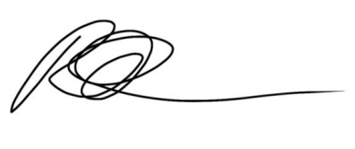

Rik Robinson
Head Teacher

‘Newfield School is committed to safeguarding and protecting the welfare of children and vulnerable adults as its number one priority. This commitment to robust recruitment, selection and induction procedure is shared by all staff and volunteers of Newfield School.’

